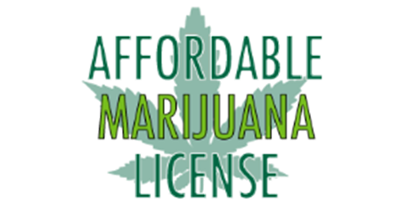

Phone #: 904-586-0041 Website: https:AffordableMarijuanaLicense.com Email: AskUs@AffordableMarijuanaLicense.com
Welcome to the Affordable Marijuana License Clinic
How to finish registration and use your card
(Please read this paper fully before beginning)
- Check your email (the one you provided us in your visit) for an email from: MedicalMarijuanaUse@flhealth.gov and use the temporary password to sign into this website: https://MMURegistry.flhealth.gov/
- As soon as you sign in, change your password. Then Click on Your Card at the top of the page. On this page you will need to do three things
  - First, Proof of Residence, you will upload a picture of your ID or driver’s license.
  - Second, Signature, type your first and last name in the box and click Submit My Card Application.
  - Third, Payment Record, Click the button that says: Click Here To Pay Online and pay the $75 state fee(+$2.75 convenience fee)
- Now you have finished registration!
- 5-10 business days from payment, you will receive an email from MedicalMarijuanaUse@flhealth.gov, stating whether you are approved or not
- Once you have received your approval email: CALL US- 904-586-0041
Or EMAIL US- ASKUS@AFFORDABLEMARIJUANALICENSE.COM
- You may log into https://MMURegistry.flhealth.gov/ to check your orders in “Your Profile” at the bottom.
- When your first order is close to expiring, please visit us at AffordableMarijuanaLicense.com to purchase an additional order, give us a call, or send us an email!

Have any questions? Don’t hesitate to reach out to us!
Please let us know if you need assistance after your appointment, we’re always happy to help!

